**Project Design Phase-I**

**Solution Architecture**

|  |  |
| --- | --- |
| Team ID | PNT2022TMID01164 |
| Project Name | Gas leakage monitoring and alerting system |
|  |  |

**Solution Architecture:**

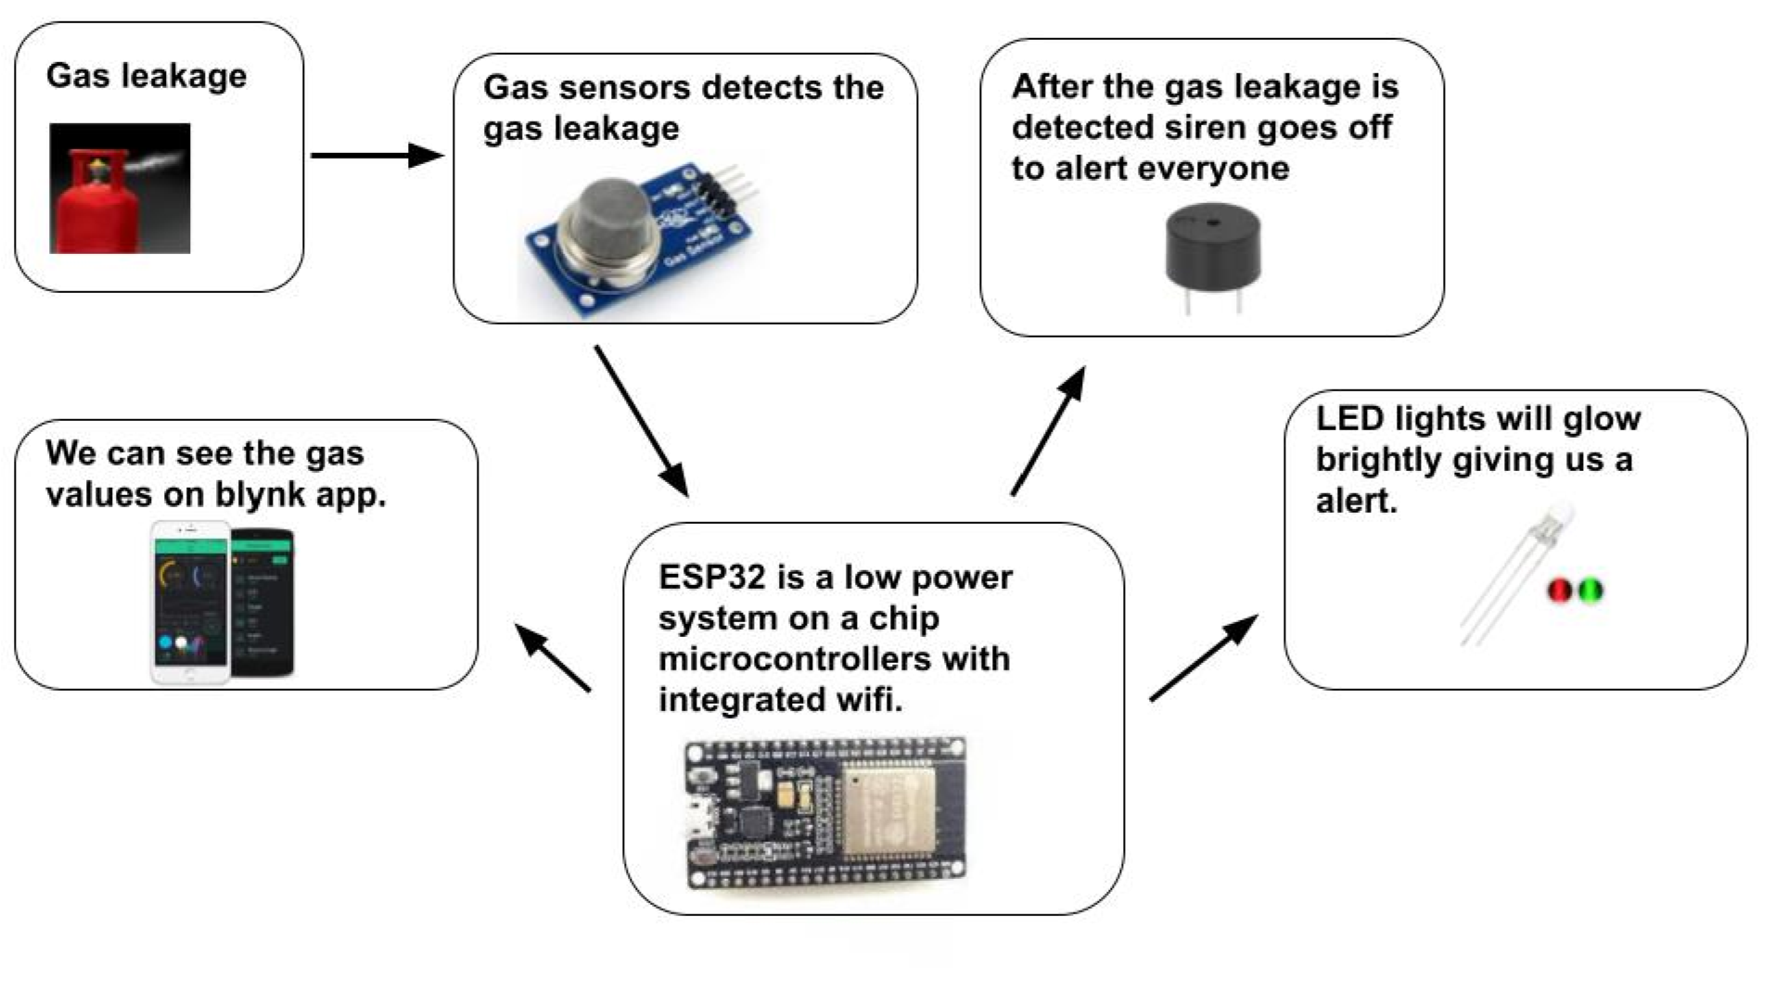

**Solution Architecture:**

Solution architecture is a complex process – with many sub-processes – that bridges

the gap between business problems and technology solutions. Its goals are to:

➢ Detects the gas level in the atmosphere continuously,

➢ If normal in gas level, green indication, one any high gas level then

follows,

➢ To construct a device that protects the people by avoiding explosions

due to gas leakage.

➢ The device must be cost effective and user friendly.

➢ That alert the peoples when there is a gas leak (LPG/PNG)

